**NAME: NISHA K**

**REG: NO: 192411231**

**EXP: NO: 5**

Create a simple cloud software application for Library book reservation system for SIMATS library using any Cloud Service Provider to demonstrate SaaS.

AIM:

To design and deploy a simple **cloud-based Library Book Reservation System for SIMATS Library** using Zoho Creator and demonstrate the concept of **Software as a Service (SaaS)**.

PROCEDURE:

1. Log in to **Zoho.com** and access the **Zoho Creator** platform.
2. Create a **new application** and provide a suitable name (e.g., *SIMATS Library Book Reservation System*).
3. Design the application by adding necessary **forms** (Book details, Student registration, Reservation form) and **reports** for tracking reservations.
4. Configure and **deploy the application** on the Zoho cloud platform.
5. Share the application link with users, enabling SIMATS students to reserve books directly via the internet

OUTPUT:

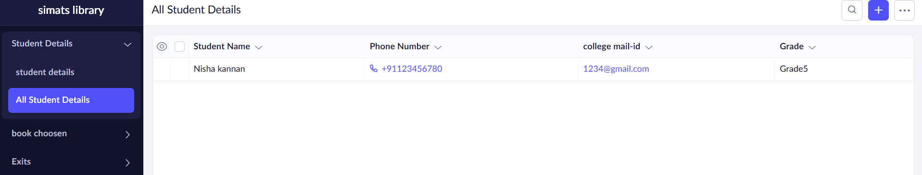

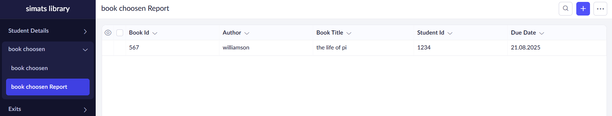

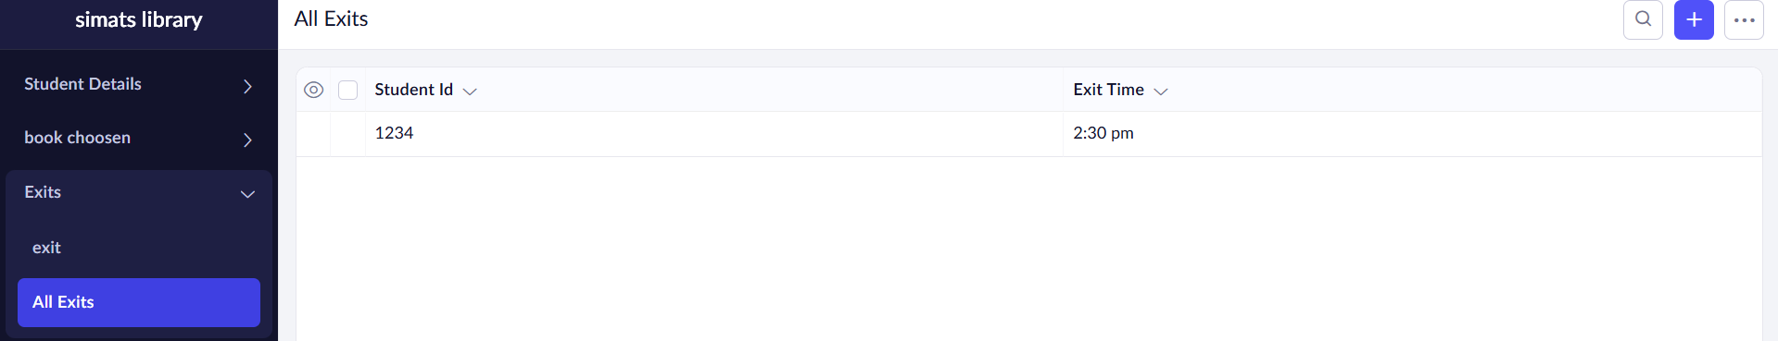

RESULT:

A Library Book Reservation System for SIMATS Library was successfully created and deployed using Zoho Creator. Students can register, search for books, and place reservations online through the cloud, thereby demonstrating the SaaS model.